

**1000+ Industry Relevant Courses || 500+ Industry Veteran Trainers**

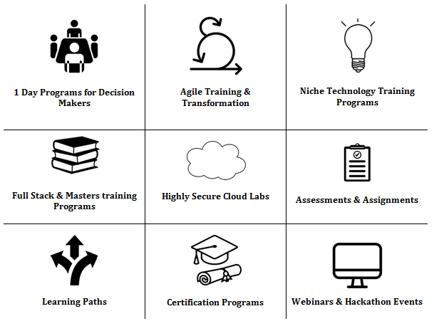

**Machine Learning & Artificial Intelligence || Internet of Things || BigData || Data Science**

**Crypto-currency & Security || DevOps || Programming Languages || Java/J2EE**

**Microsoft Technologies || Mobile & Web Technologies || Business || Agile**

|  |
| --- |
| **Course Name** |

**SpringBoot Microservices**

|  |
| --- |
| **Duration** |

**4 Days**

|  |
| --- |
| **Lab Setup** |

**HW :** 1 Laptop Per Participant with 8GB RAM and 100 GB Disk Space

**OS :** Windows

**SW :**

  1. Admin access  
  2. JDK 8+  
  3. Eclipse Java IDE   
  4. Proxy-free internet access  
  5. A Text Editor like Sublime  
  6. MySQL Database  
  7. Postman  
  8. Google Chrome Browser

|  |
| --- |
| **Course Contents** |

|  |  |
| --- | --- |
|  |  |
| **SPRING BOOT Introduction** | Spring Boot starters, CLI, Gradle plugin |
|  | Application class |
|  | @SpringBootApplication |
|  | Dependency injection, component scans, Configuration |
|  | Externalize your configuration using application. properties |
|  | Context Root and Management ports |
| **Using Spring Boot** | Build Systems, Structuring Your Code, Configuration, Spring Beans |
|  | Dependency Injection, and more. |
|  |  |
| **Spring Boot Essentials** | Application Development, Configuration, Embedded Servers, Data Access, and many more |
|  | Common application properties |
|  | Auto-configuration classes |
|  | Spring Boot Dependencies |
| **Spring Data REST** | Introduction & Overview |
|  | Adding Spring Data REST to a Spring Boot Project |
|  | Configuring Spring Data REST |
|  | Repository resources, Default Status Codes, Http methods |
|  | Spring Data REST Associations |
|  | Define Query methods |
| **Microservices** | Overview of microservices |
|  | Advantages and disadvantages of microservices |
|  | Creating the simple microservice |
|  | setting up spring cloud config server |
|  | Eureka naming server |
|  | Connecting microservice to eureka |